Vibration Sensor (iSN-713) to Laptop / Backend – Complete Setup Guide
Purpose: This document explains, step by step, how vibration data was successfully obtained from the iSN-713 Modbus RTU vibration sensor using a TGW-718 Modbus TCP gateway, verified via Modbus tools, and finally made available to a backend system.
Note: Code snippets are intentionally skipped. Space is left for screenshots (SS) where indicated.

1. Hardware Used
- iSN-713 MRTU Vibration Sensor
- TGW-718 Modbus RTU → Modbus TCP Gateway
- 12V DC Power Adapter (for TGW-718)
- RS-485 Cable (Sensor → Gateway)
- Ethernet Cable (Gateway → Network)
- LAN to USB-C Converter (Laptop without Ethernet port)
- Laptop / PC

2. Physical Connections

2.1 Power Connections
- TGW-718 powered using 12V DC adapter
- iSN-713 powered as per datasheet (via RS-485 / external supply)

2.2 RS-485 Wiring (Sensor → Gateway)
iSN-713 | TGW-718
D+ | Data+
D- | Data-
- Ensure correct polarity (D+ to D+, D- to D-)
- Keep cable length short and twisted pair preferred

2.3 Ethernet Connection
- TGW-718 Ethernet port → LAN cable
- LAN cable → USB-to-Ethernet adapter → Laptop

3. TGW-718 Initial Configuration

3.1 RUN / INIT Switch
- Set switch to INIT for reset / IP recovery
- Power ON → wait 10 seconds
- Power OFF → set switch to RUN
- Power ON again
This restores default network and login settings.

3.2 Network Settings
- Default IP of TGW-718: 192.168.1.100
- Laptop Ethernet IP set manually, e.g.:
  - IP: 192.168.1.10
  - Subnet: 255.255.255.0
Test connectivity: - Ping 192.168.1.100
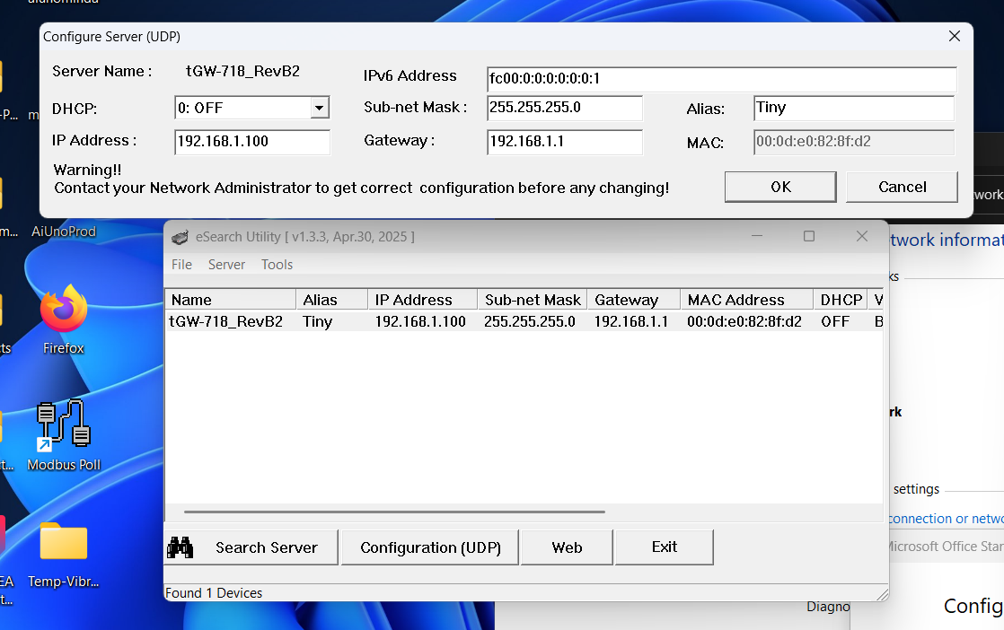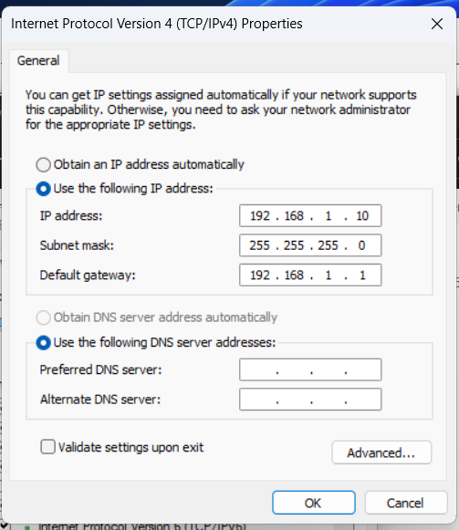

4. Accessing TGW-718 Web Interface
- Open browser → http://192.168.1.100
- Login page may not visibly change after submit
- Default password used: admin
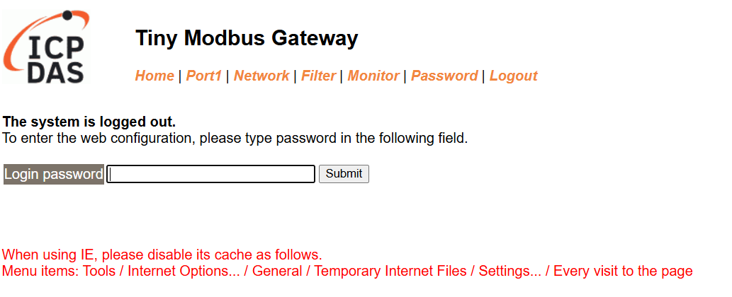

5. Serial (RS-485) Configuration in TGW-718

5.1 Port Settings
Configured according to iSN-713 quick start guide:
- Baud Rate: 9600
- Data Bits: 8
- Parity: None (disabled / fixed by device)
- Stop Bits: 1
- Mode: Modbus RTU Master
⚠️ Parity option may be disabled – this is normal for TGW-718 firmware.

5.2 Modbus Mapping Mode
- TGW-718 configured as:
  - RTU (sensor side) → TCP (network side)
- Gateway acts as Modbus TCP slave on port 502

6. Understanding iSN-713 Modbus Data
The iSN-713 does not provide X/Y/Z axis data.
Instead, it provides scalar vibration metrics via Input Registers (3xxxx).

6.1 Registers Used
Register | Meaning
30023 | Acceleration RMS
30024 | Acceleration Max
30025 | Acceleration Peak-to-Peak
30026 | Crest Factor
30027 | Velocity RMS

6.2 Scaling Rules
- Acceleration values → mg (milligravity)
- Crest factor → value × 0.01
- Velocity RMS → value × 0.01 mm/s
Example raw data:
[ 10, 58, 56, 54, 38 ]
Converted values: - Accel RMS: 10 mg - Accel Max: 58 mg - Accel P-P: 56 mg - Crest Factor: 0.54 - Velocity RMS: 0.38 mm/s

7. Verifying Data Using Modbus Tool
Before backend integration, data was verified using:
- Modbus Poll / Modbus Doctor
- Connection type: Modbus TCP
- IP: 192.168.1.100
- Port: 502
- Slave ID: 1
- Function Code: 04 – Read Input Registers
- Start address: 30023
- Length: 5
⚠️ Only one Modbus master should be connected at a time.
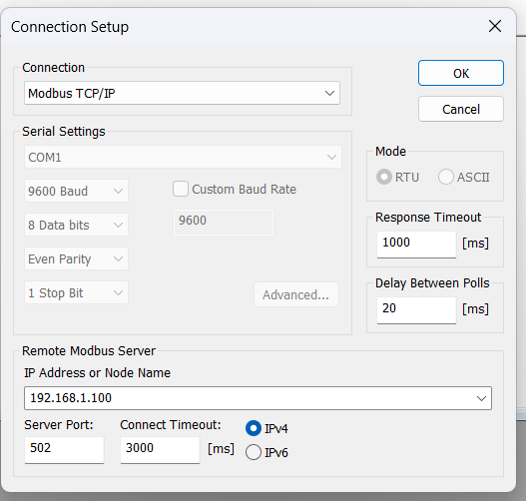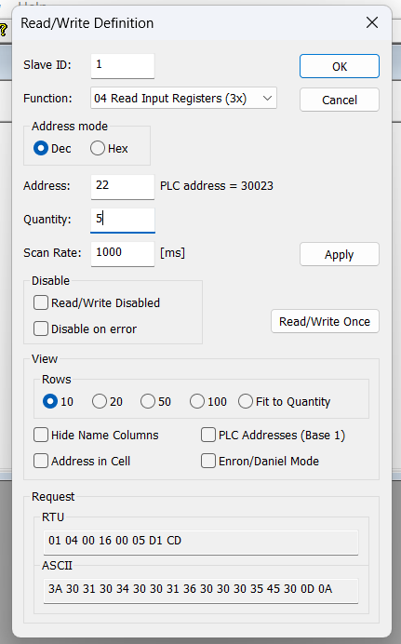

8. Backend Integration Overview (High Level)
- Backend connects to TGW-718 using Modbus TCP
- Polls input registers periodically (e.g., every 1 second)
- Converts raw register values into engineering units
- Emits live data via WebSocket
- Stores structured data into MongoDB

9. Final Data Model (Conceptual)
Each vibration sample consists of:
- Timestamp
- Acceleration (RMS, Max, Peak-to-Peak)
- Velocity RMS
- Crest Factor
- Raw register values (for debugging & traceability)
This model supports: - Live dashboards - Historical analysis - Alarm thresholds - Predictive maintenance

10. Result
✔ Stable Modbus TCP communication ✔ Real-time vibration data available ✔ Data validated against Modbus tools ✔ Ready for frontend visualization and alerts

11. Next Possible Enhancements
- ISO 10816 vibration severity limits
- Alarm & notification system
- FFT spectrum analysis (if supported)
- Data downsampling & aggregation
- Cloud deployment

